EC DECLARATION OF CONFORMITY
1.
Product Identification No. AYR-BP-004 Youth Batting Pad.
2.
Name and address of the manufacturer and/or his authorised representative:
Ayrtek Cricket Limited
51 Lewis Road
Bristol
BS13 7JD
3.
This declaration of conformity is issued under the sole responsibility of the manufacturer (or installer):
Tandon International
Mandi Road
Jalandhar
Punjab
India
144001
+91-9888084321
tandon.international@yahoo.in
4.
Object of the declaration (identification of product allowing traceability. It may include a photograph, where appropriate):
Youth Batting Pad
There are 4 Colour variations of green, blue, gold and white.
They are available in 2 dexterities being Right Handed or Left handed model.

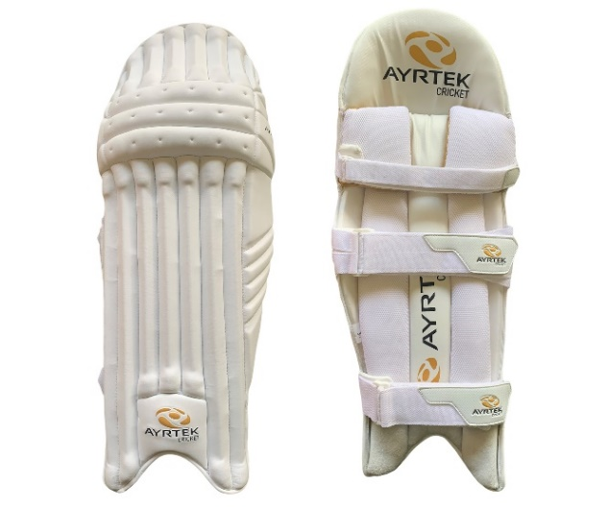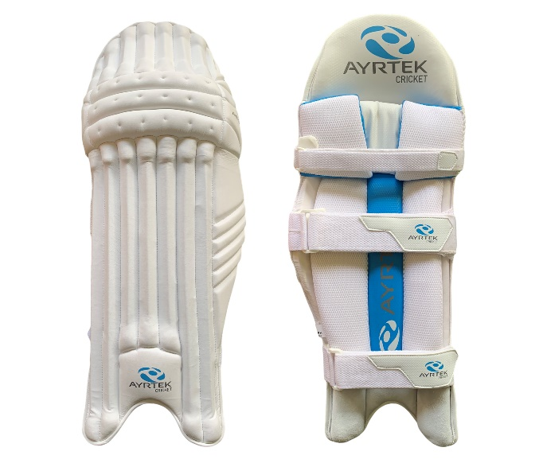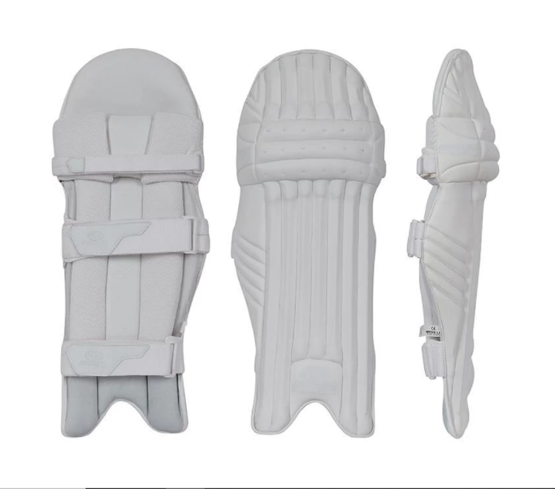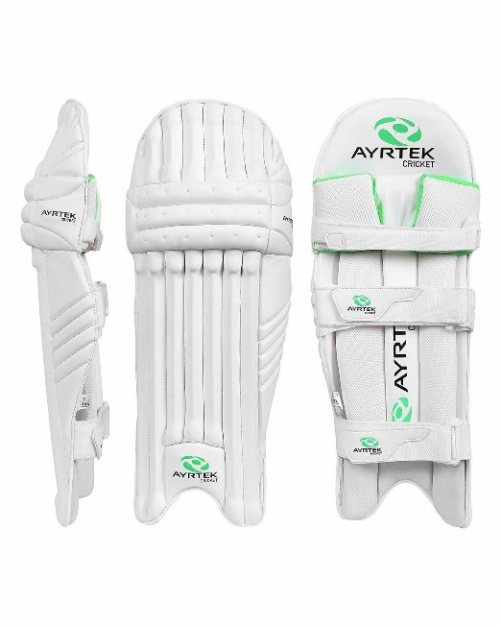
5.
The object of the declaration described above is in conformity with the relevant Community harmonisation legislation: REGULATION (EU) 2016/425 OF THE EUROPEAN PARLIAMENT AND OF THE COUNCIL of 9 March 2016 on personal protective equipment and repealing Council Directive 89/686/EEC
6.
References to the relevant harmonised standards used or references to the specifications in relation to which conformity is declared:
BS 6183-1:2000- Protective equipment for cricketers
BS 6183-3:2000- Protective equipment for cricketers Part 3: Leg protectors for batsmen,
wicket keepers and fielders, and thigh, arm and chest protectors for batsmen

7.
Where applicable, the notified body performed- BS 6183-1:2000
8.
Additional information:

PAD MATERIALS

PAD IS MADE OF HIGHEST QUALITY KOREAN LOVELONE FOAM PROTECTION

Pad Materials
A. PLASTIC / CANE RODS ON FRONT, COTTON / THICK 20MM FOAM PADDING KNEE
B. ETHOFLEX SHEET 10MM HIGH DENSITY ON THE BACK SIDE OF THE RODS
C. ETHOFLEX SHEET 15MM HIGH DENSITY ON THE WING AREA
D. THICK PLASTIC KNEE CUP IN THE KNEE AREA
E. 10MM LOW DENSITY SHEET ON THE BACK SIDE OF SHIN BOLSTER
F. 25MM UFOAM IN THE KNEE BOLSTER AND SHIN BOLSTER
G. 10MM LOW DENSITY SHEET ON THE TOP OF SHIN BOLSTER
H. 1MM PLASTIC FIBER THROUGH OUT SHIN BOLSTER

THICK LEATHER INSTEP, 12MM LOW DENSITY FOAM IN INSTEP, COTTON PADDING IN MIDDLE OF INSTEP
Signed for and on behalf of: Ayrtek Cricket Limited

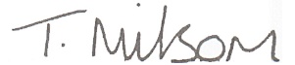
Tom Milsom, Company Director
Date- 01/01/2021

